Task 2.1P

Link for repo:

Screen shot of code:

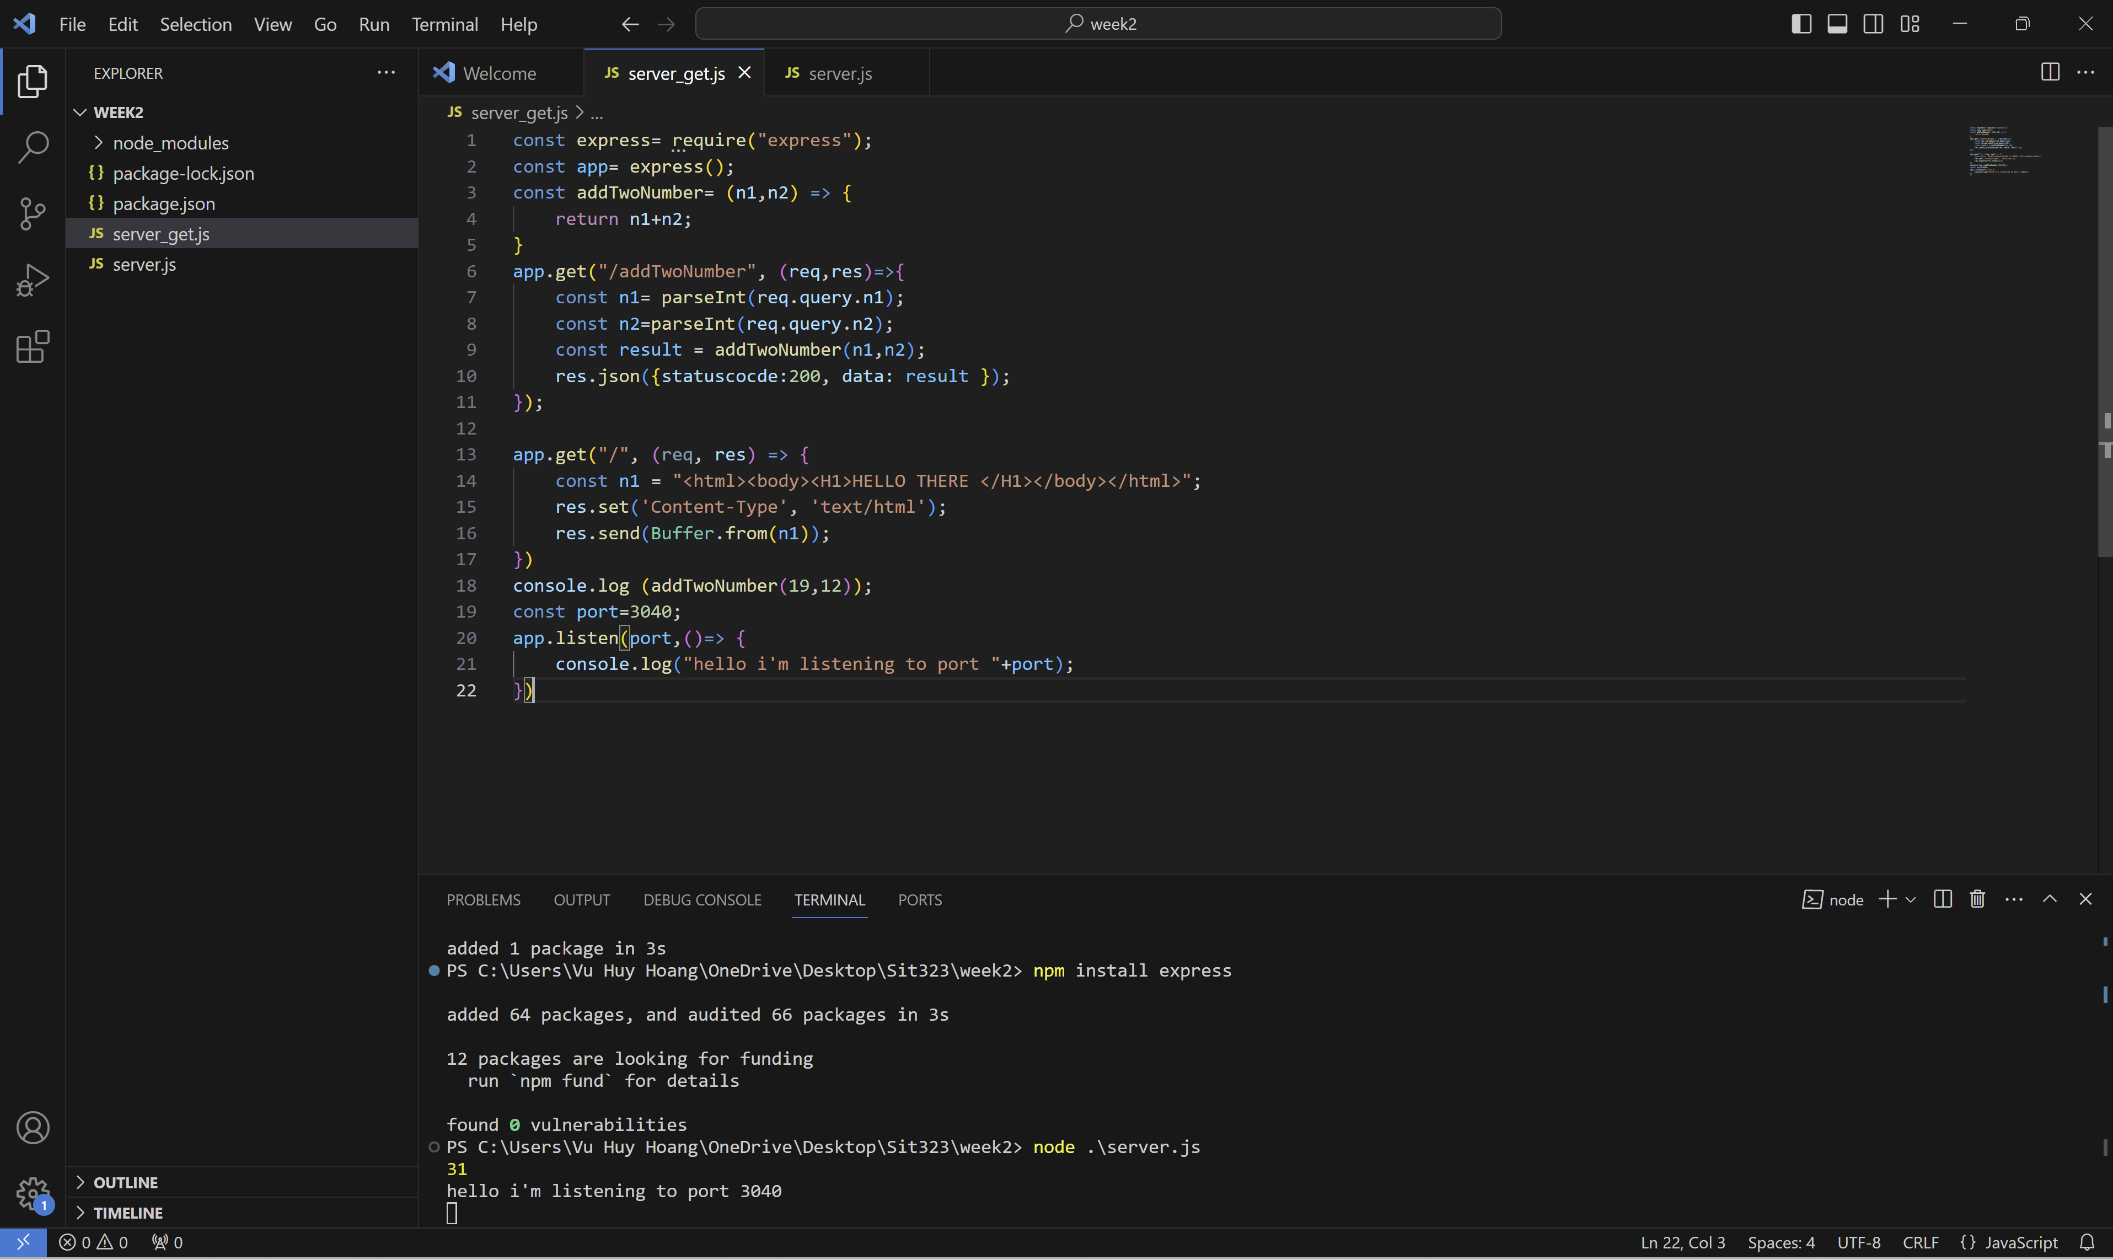

Output:

